Nama : Cipyanto

Nim : 1300631020

LAPORAN

1. Buka sourcode GuiScan dengan menggunakan IP yang ada pada leptop si pengguna yang tertera pada gambar di bawah ini.

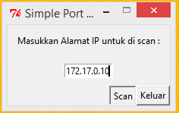

1. Kemudian muncul Port 135 dan port 139 yang seprti gambar di bawah ini.

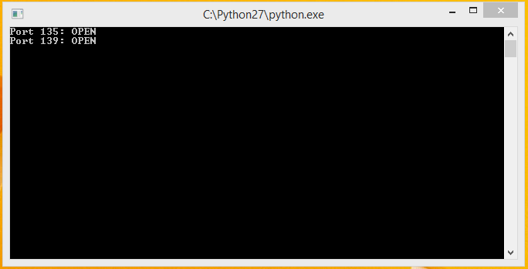

1. Penjelasan Port yang ada pada gambar di atas?
2. Port 135

TCP Port 135 – RPC Message Queuing  
  
TCP Port 135 – RPC Remote Procedure Call  
  
TCP Port 135 – RPC Exchange Server  
  
TCP Port 135 – RPC Certificate Services  
  
TCP Port 135 – RPC Cluster Service  
  
TCP Port 135 – RPC Distributed File System  
  
TCP Port 135 – RPC Distributed Link Tracking  
  
TCP Port 135 – RPC Distributed Transaction Coordinator  
  
TCP Port 135 – RPC Event Log  
  
TCP Port 135 – RPC Fax Service  
  
TCP Port 135 – RPC File Replication  
  
TCP Port 135 – RPC Local Security Authority  
  
TCP Port 135 – RPC Remote Storage Notification  
  
TCP Port 135 – RPC Remote Storage Server  
  
TCP Port 135 – RPC Systems Management Server 2.0  
  
TCP Port 135 – RPC Terminal Services Licensing  
  
TCP Port 135 – RPC Terminal Services Ses

1. Port 139

TCP Port 139 – NetBIOS Session Service Computer Browser  
  
TCP Port 139 – NetBIOS Session Service Fax Service  
  
TCP Port 139 – NetBIOS Session Service Performance Logs and Alerts  
  
TCP Port 139 – NetBIOS Session Service Print Spooler  
  
TCP Port 139 – NetBIOS Session Service Server  
  
TCP Port 139 – NetBIOS Session Service Net Logon  
  
TCP Port 139 – NetBIOS Session Service Remote Procedure Call Locator  
  
TCP Port 139 – NetBIOS Session Service Distributed File System  
  
TCP Port 139 – NetBIOS Session Service Systems Management Server 2.0  
  
TCP Port 139 – NetBIOS Session Service License Logging Service